Teach-by-Demonstration Pilot Study

(Pilot Testing Protocol)
Version 1.0

Overview
This document outlines the process for executing a trial teach-by-demonstration data collection study. The study simulates a human subject trial in which a volunteer goes through the process of controlling a robot and its attached gripper to complete a sample assembly task. While the actual human subject study will leverage the NIST assembly taskboards, this assembly task is simplified to a pick-and-place operation of cubes into a grid. This simplification is for the sake of expediting the time necessary to complete the assembly.

The purpose of this study is to evaluate the efficacy of the testbed setup, data collection, and post-process data alignment and packaging.

Training the Study Volunteer
Use the attached volunteer overview document to provide a convenient reference guide for the volunteer.

Provide a brief overview of robot safety, including the following points:
- Emergency stops
- Freedrive mode
- Joint limits and automatic deactivation

Provide a brief overview of the data being collected, including the following:
- Video of the volunteer operating the robot
- Point cloud data of the testbed environment, including the volunteer.
- Position and state data from the robot, which includes joint angles, Cartesian coordinates of the gripper, measured forces, etc.
- State data from the gripper, including button presses and aperture of the gripper.
- Screen recordings of the teach pendant.
- Time codes for each of the data streams.

Provide a brief summary of the controls for the robot.
- Demonstrate the gripper actuation
- Demonstrate freedrive mode
- Demonstrate picking up and putting down an object

Allow the study participant to practice controlling the robot and picking up and placing objects within the testbed. Reset the testbed prior to beginning the trial.

Testbed Setup and Starting the Recording Process

Prior to starting the testing process, set up the staging area with the five cubes. Each cube goes into a specific slot on the staging area fixture:
Blue: Slot 1  Green: Slot 2  Yellow: Slot 3  Orange: Slot 4  White: Slot 5 | 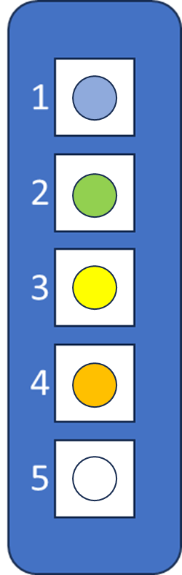

The 5x5 target grid should be empty of all blocks.

The robot’s J6 should be oriented such that the gripper control flange is pointed to the side with the participant’s dominant hand (left or right).

A second tester must be present to provide emergency services, including being stationed with an emergency stop button to stop the robot in the event of dangerous motions.

Teach-By-Demonstration Process Description
The volunteer will be instructed to control the robot using the on-arm button interface to pick up and place cubes in a specific order.

When the participant is ready, start recording for all data streams.

For each pick-and-place operation, provide a card stating which cube is to be picked up, and the 2-digit location of the target receptacle of the block. Give the participant only one card at a time, and provide the next card only after the current object has been placed.

Teach-by-Demonstration Pilot Study

(Volunteer Reference Sheet)

Safety
Before beginning the test, please familiarize yourself with the safety functions of the robotic testbed.

An emergency stop button (large red button with an orange and black base) is provided for your benefit. If at any time the robot or its actions make you feel unsafe, press the red button and the robot will stop immediately. Stopping the robot in this manner requires a manual restart (the button must be manually released, and the robot re-enabled to allow it to move again), so it is impossible for the robot to automatically restart itself.

During the trials, one of the testers will also be watching the robot’s actions, and will have their own, separate emergency stop button. This tester’s singular responsibility is to ensure your safety.

The robot also constantly monitors its functional state, and will disable itself if aberrant actions are detected. Aberrant actions include:
- Moving faster than a set, maximum speed,
- Rapid acceleration (including impacts)
- Excessive force, and
- Encountering physical joint limits (the robot’s joints cannot be turned infinitely due to hardware limitations).
- Encountering virtual position limits (the robot may be configured to prevent it moving beyond certain position thresholds; e.g., attempting to move below the table surface)

While working with the robot, it is recommended you tie back any loose hair or clothing to prevent accidentally being snagged on the robot, its gripper, or the various parts in the testbed. Keep hands, hair, and clothing away from the gripper while it is opening or closing. Although commanded forces have been reduced to prevent injury, it may be startling or slightly uncomfortable if you get pinched.

All sensitive or personal equipment (jewelry, name badges, etc.) should be removed prior to beginning the trial. A bin will be provided to deposit these materials.

Task Overview
During this study, your task will be to move cubes from a staging area (left column) to specific locations on the target board (right grid). You will be instructed which block to move from the staging area using its numerical position in the column, and where on the grid to move the block using its column and row combination. Each block will have a colored indentation on the top, but this is not relevant to this test.

For example, you may be asked to move block #2 to position E1 on the grid, in which case you will use the robot to pick up the block from the staging area in space 2 (second from the top), and then move it to location E1 (top right square) on the grid. While each block will have a color associated with it, these colors are not part of this test.

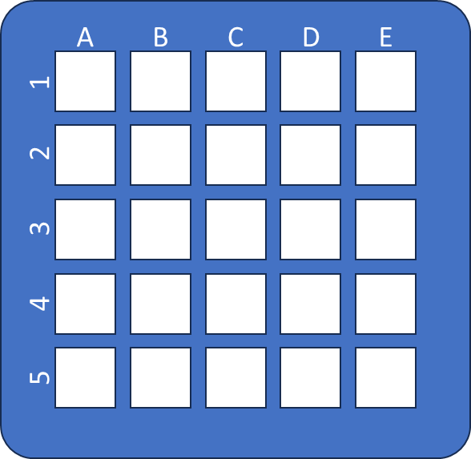

The order of the pick-and-place operations does matter, so please try to do each action in the order it is given to you.

Note that you will not be allowed to correct erroneous placement of objects. Simply move on to the next object.

The duration of the test will be timed. However, the goal of this test is to evaluate task accuracy, and not to determine how quickly you can complete it.

Additional measurements that will be recorded include:
- Video and audio of the test,
- Point cloud data (i.e., a series of dots in three dimensions that show where the surfaces of people and objects are in the environment)
- Task accuracy as a percentage of maximum number of correct placements, and as a measure of order of operations,
- Robot and gripper joint configurations,
- Gripper location,
- Incurred forces and torques, and
- Button presses

Robot Controls
For this experiment, you will be controlling the robot manually by means of a button interface attached to the robot’s gripper. The interface consists of a collar attached to the robot, just above a robotic gripper. The protrusion with the buttons is double-sided, and has an identical button layout on the opposite side.

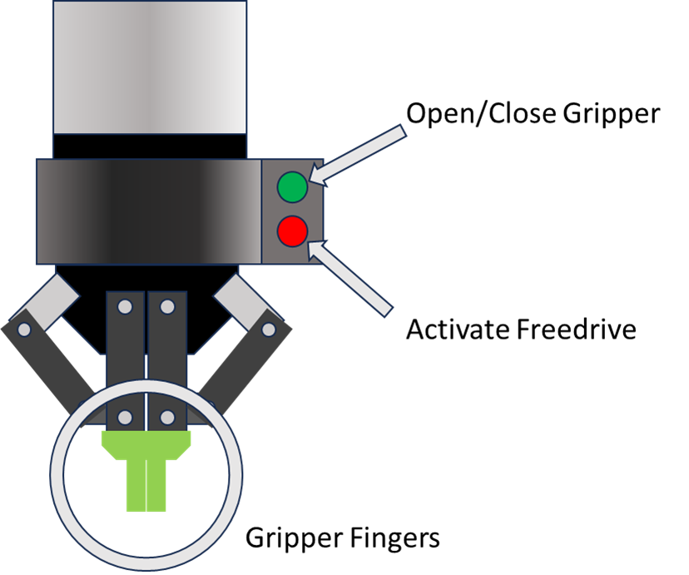

The top buttons (green) control the gripper, and cycle between “open” (the green “fingers” are spread apart) and “closed” (the green fingers are close together). To actuate the gripper, simply simultaneously press the two green buttons on both sides of the gripper, hold for about half a second, and then release. If the gripper is open, this will close it; and if the gripper is closed, it will open it again.

The bottom buttons (red) enable the robot’s “freedrive” mode. In freedrive mode, the brakes release and the robot will allow you to push and pull it into different joint configurations. While in freedrive mode, the robot is active, and is interpreting the forces you are applying to it as motion commands. Pressing and holding the red buttons will enable freedrive mode. Freedrive mode will remain active while both buttons are pressed. Releasing the buttons will disable freedrive, and the robot’s brakes will engage again.

The following instructions are recommended to ensure smooth operations:
- When using freedrive mode, hold the gripper with both hands to provide the maximum level of control.
- Do not attempt to move the robot quickly. Completion time is not part of this test.

Teach-by-Demonstration Pilot Study

(Subject Information and Informed Consent Form)

A sample test methodology for subject data collection as part of a new research testbed for human-robot interaction.

Qualified investigator: Megan Zimmerman
Sub-investigator(s): Jeremy Marvel and Shelly Bagchi

Introduction:
You are being invited to participate in a research study (also known as a “test” or “trial”). This research is part of a pilot, and will focus on the collection of data for the verification and validation of a testing methodology and is not part of a larger human subject study. The data collected will be used to evaluate and calibrate the processes for disparate data stream synchronization and alignment.

Including the time necessary to explain the purpose of this study (including training, reading the reference materials and this consent form, and conducting the teach-by-demonstration trial) is expected to take no longer than 30 minutes.

It is your choice if you want to participate in this study.

This form explains why we are conducting this study, the nature of the data being collected, and how this data is being stored and protected.

What is the purpose of this study?
The purpose of this study is to generate test data for the evaluation of the methodologies of data collection, data synchronization, and automated data segmentation and analysis. The research questions being addressed are:
Are the processes of collecting data accurate and repeatable?
What is the uncertainty of the data alignment methodology?
Is the collection of sensors meaningful for the evaluation of human-robot interaction?

Who can take part in this study?
To take part in this study, you must be at least 18 years of age, be able to see objects in the environment with or without visual aids, have full functionality of at least one arm and hand, and be able to listen to and understand instructions presented in English.

What will we ask you to do?
You will be trained to use an industrial robot with a simplified interface to simulate a teach-by- demonstration programming process. Following this, you will be asked to complete a series of five (5) pick-and-place operations using a small industrial robot, guided by hand, with a robotic gripper controlled using buttons attached to the robot. You will be instructed on the order of the objects to pick up, and where to place them on a grid.

Risks and discomforts
Physical risk: The robot and its gripper are controlled manually and at a reduced speed. It is possible, however, that study participants could get pinched by the gripper or caught between the robot and the test surface. Minor bruising may be possible under such circumstances.
Security risk: This pilot study includes the use of video equipment with which the face or other personally identifiable physical features of the participant may be recorded. All data collected during this study will be securely stored on a password-protected drive, and are to be used only for internal purposes (i.e., no data containing personally-identifiable information will be publicly released).

Benefits
Participation in this study will produce valuable data that will be used to validate and fine-tune the testing protocols, that will, in turn, be used as bases for establishing standards for human-robot interaction research as part of the IEEE P3108 committee on recommended practices for human-robot interaction.

If you have questions
If you have any questions following this study, or would like to know more about the resulting collected data, please contact Megan Zimmerman, Computer Scientist in the NIST Intelligent Systems Division. You may ask questions now, or contact Megan at megan.zimmerman@nist.gov. You may also request a copy of this consent form by contacting Megan at the above address.

Statement of Consent
I have read the above information, and have received answers to any questions I asked. I consent to take part in the study and have my likeness recorded for the purpose of test protocol verification.

Your Signature: ____________________________________________

Your Name (printed): _________________________________________

Date: _____________________________________

Signature of person obtaining consent: ____________________________________________

Printed name of person obtaining consent: _________________________________________

Date: _____________________________________

This consent form will be kept by the researcher for at least three (3) years beyond the end of the study.

Teach-by-Demonstration Pilot Study

(Testing Scenarios)

Scenario 1:
 | Block |  |  |  |  | 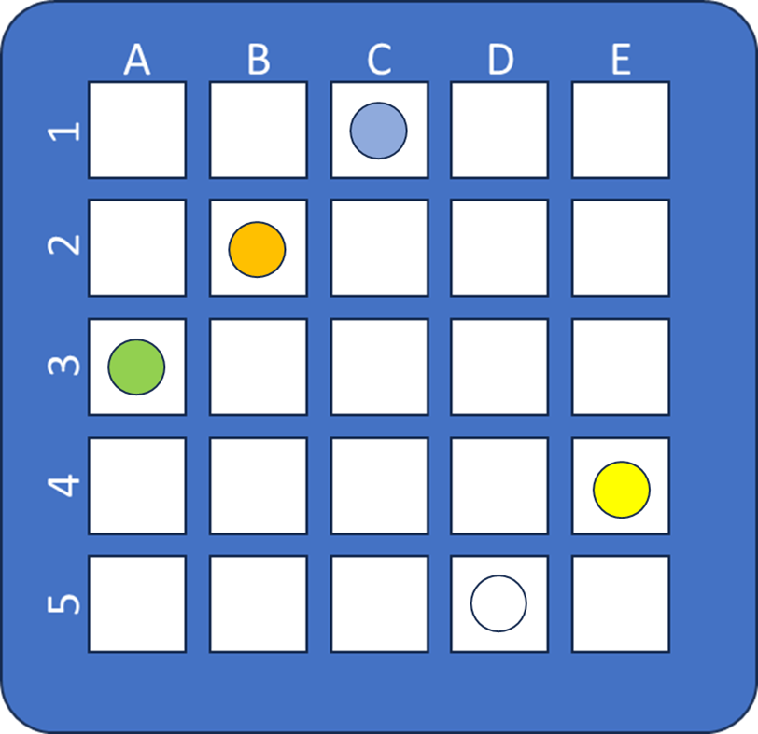
 | 1 | 2 | 3 | 4 | 5
Target Location | C1 | A3 | E4 | B2 | D5

Scenario 2:
 | Block |  |  |  |  | 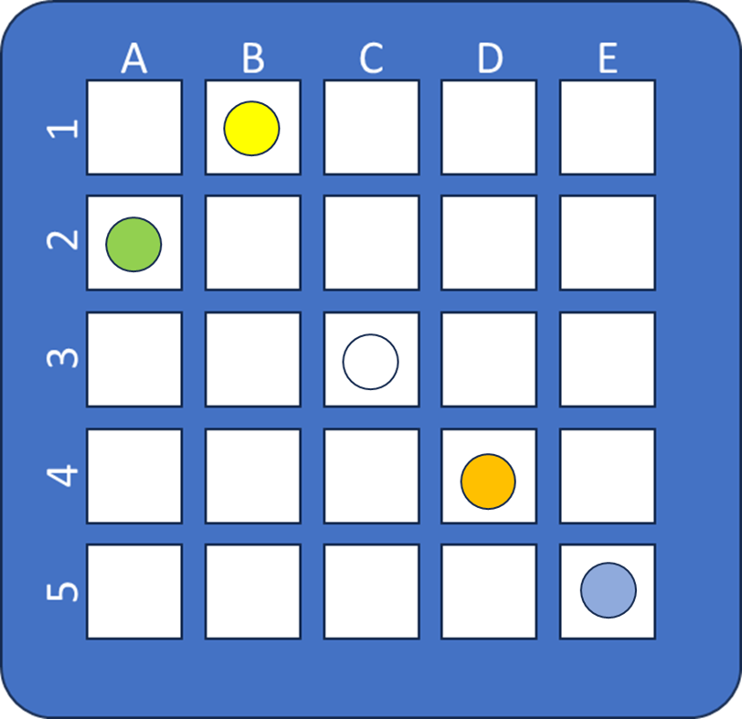
 | 1 | 2 | 3 | 4 | 5
Target Location | E5 | A2 | B1 | D4 | C3

Scenario 3:
 | Block |  |  |  |  | 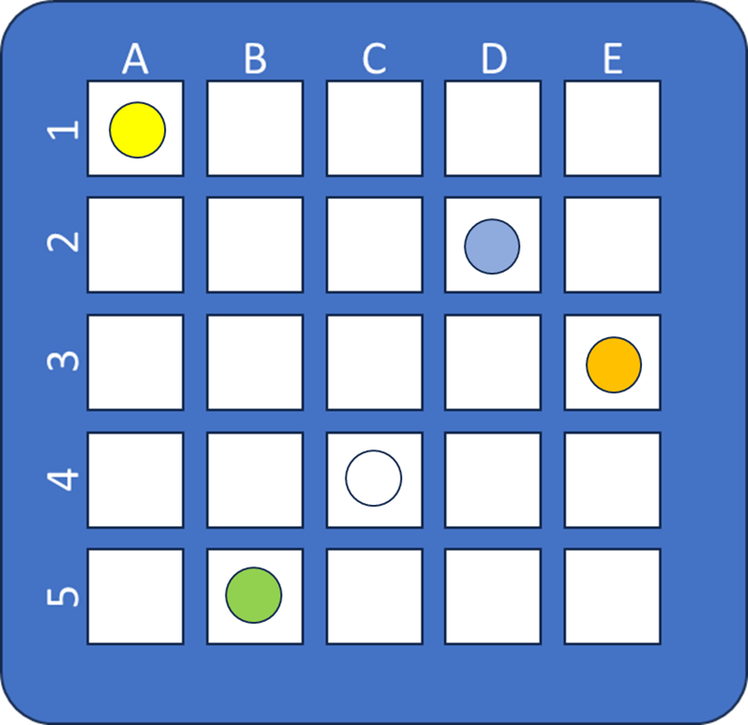
 | 1 | 2 | 3 | 4 | 5
Target Location | D2 | B5 | A1 | E3 | C4

Scenario 4:
 | Block |  |  |  |  | 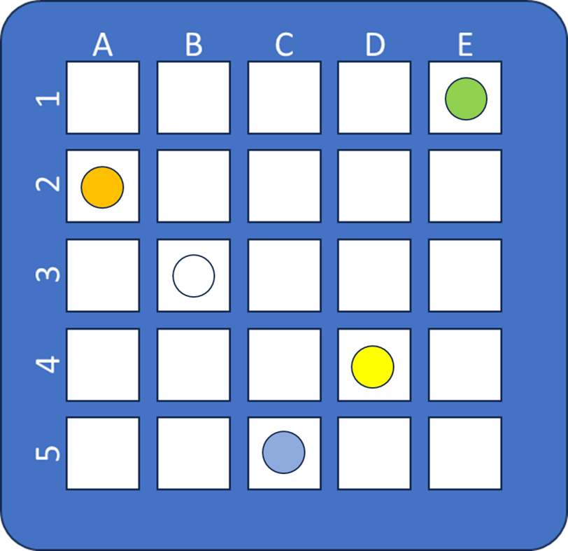
 | 1 | 2 | 3 | 4 | 5
Target Location | C5 | E1 | D4 | A2 | B3

Scenario 5:
 | Block |  |  |  |  | 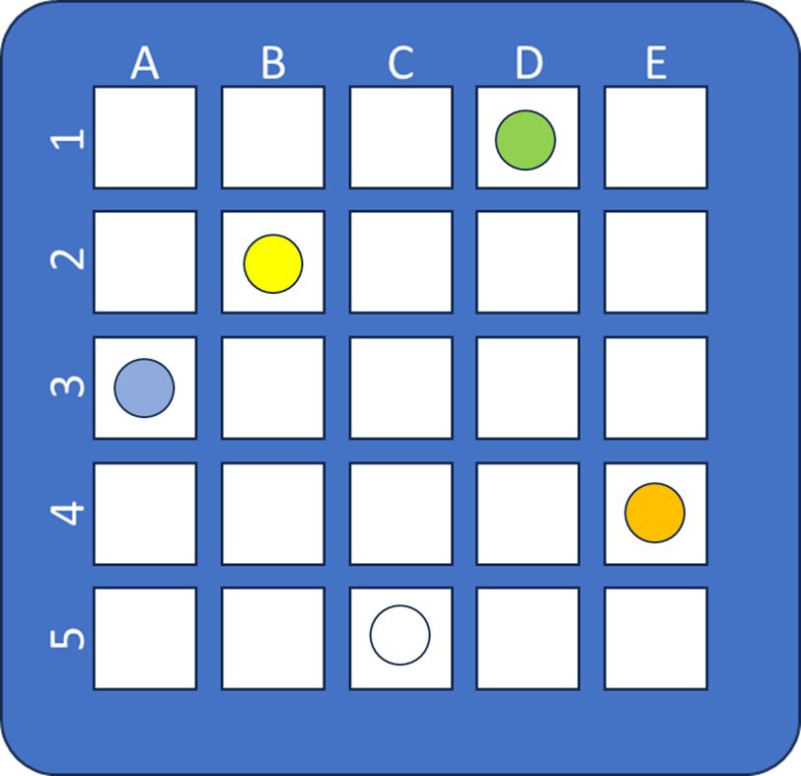
 | 1 | 2 | 3 | 4 | 5
Target Location | A3 | D1 | B2 | E4 | C5

